1. Install “devtools” package, and saved my R function for count the prime numbers in Folder “R”.

**Function for Count the prime numbers-**

CountPrime <- function(num){

values <- rep(TRUE, num)

values[1] <- FALSE

prev.prime <- 2

for(i in prev.prime:sqrt(num)){

values[seq.int(2 * prev.prime, num, prev.prime)] <- FALSE

prev.prime <- prev.prime + min(which(values[(prev.prime + 1) : num]))

}

return(which(values))

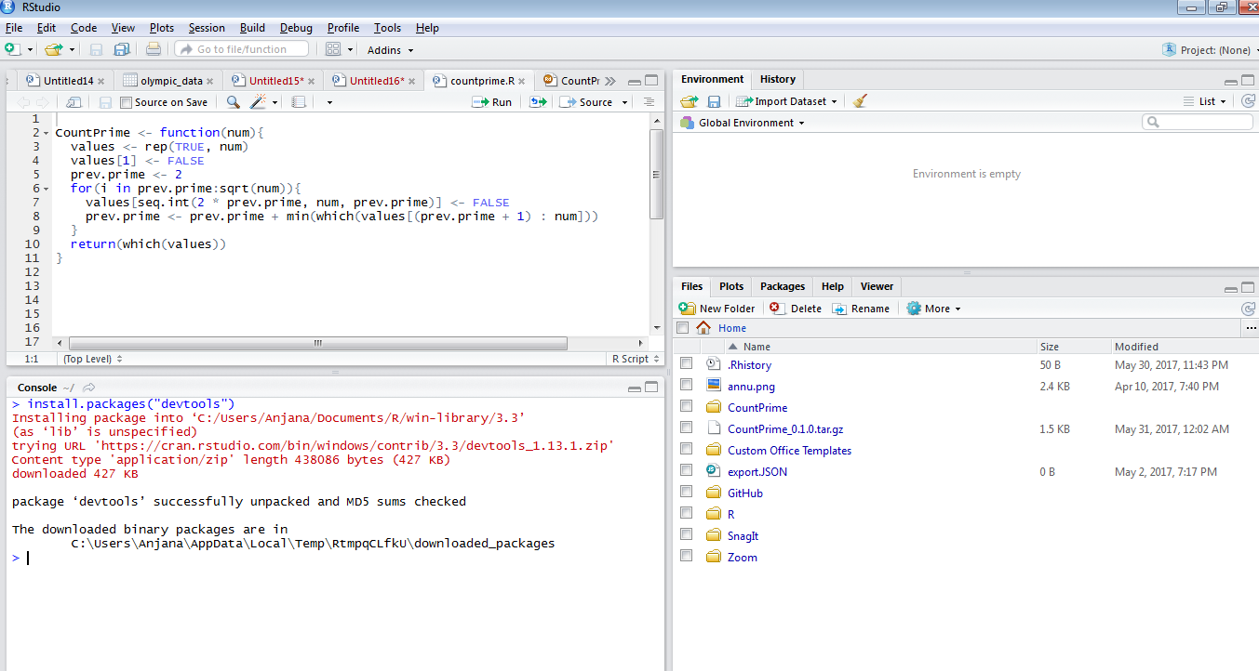

1. 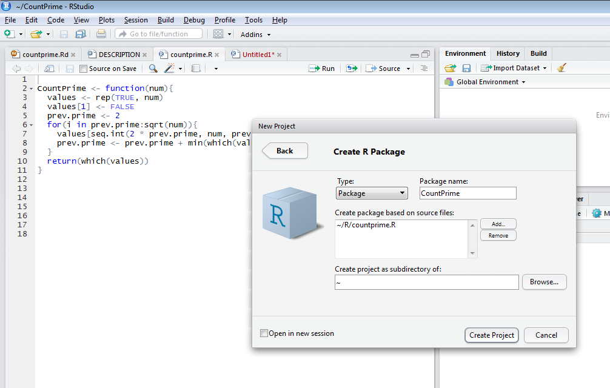Now open a new project in RStudio throungh ‘File’ menu and click on ‘New Project.’ Then select ‘New Directory,’ and ‘R Package’ to create a new R package. Then add my code source from “add” button.
2. Now in Description file, do the modification like – title, author’s name etc.

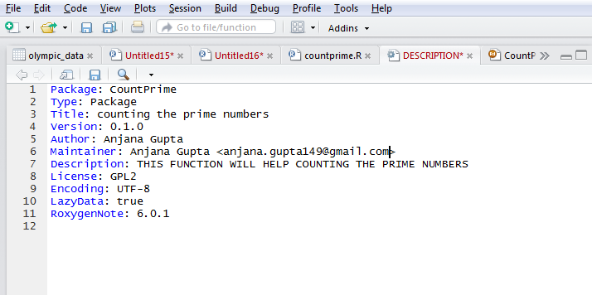

1. In “Man” folder too do the changes in countprime.Rd.

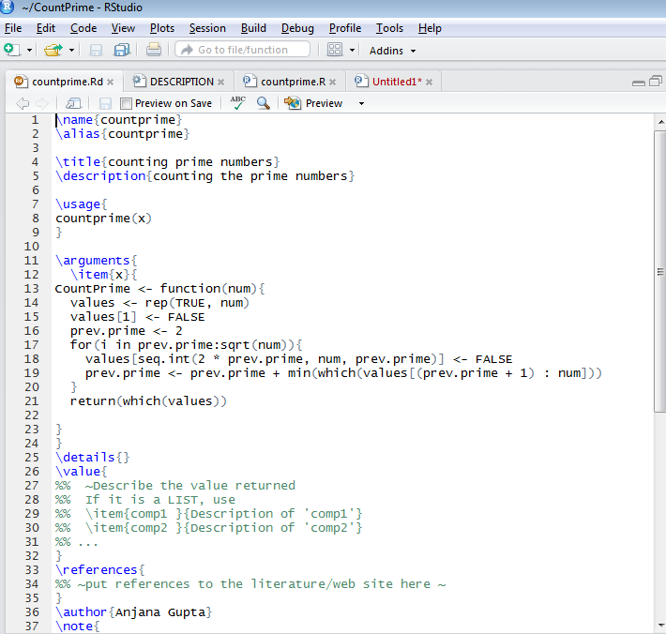

1. Now go to the “Build” Button top of the Rstudio and select “Build and Reload”

